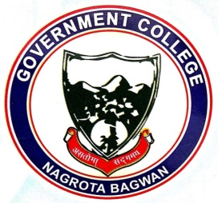
GOVERNMENT COLLEGE
NAGROTA BAGWAN
Distt. Kangra (H.P.)-176047
Tel.: 01892-251177
Emailid: gcnagrotabagwan@gmail.com

Link of Extension Activities Conducted in Collaboration with Industry, Community and Non- Government Organizations through NSS/ NCC/ Red Cross/ YRC etc., during 2022-23

- http://gdcnb.org/wp-content/uploads/2024/04/Annual-Report-NSS-2022-23.pdf
- http://gdcnb.org/wp-content/uploads/2024/04/Annual-Report-Red-Ribbon-Club-2022-23.pdf

